- OCEAN BREATH –
Compliments of The Holistic Garden
Serves 3

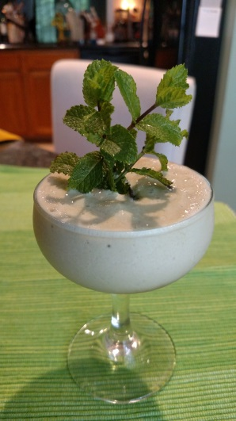

This dish is made with a new ingredient I recently discovered called SEA MOSS.

Considered a Super Food, this algae contains 92 of the 102 minerals the human body needs daily, among a huge list of other health benefits.

SEA MOSS can be transformed into a variety of mediums that is adaptable to a wide range of culinary dishes for day to day cooking.

OCEAN BREATH is a Nutritional Protein Drink I developed a few weeks ago using SEA MOSS GEL.
It goes something like this!

EQUIPMENT LIST
Blender
Rubber spatula

INGREDIENT LIST
1 can Coconut Milk…full fat(not cream)
1 packet TLS Vanilla Whey Protein Powder
1 tablespoon Frontier Organic Matcha Green Tea Powder
3 tablespoons of The Holistic Garden’s SEA MOSS GEL – NEW
Sweeten to taste with your favorite sweetener – NO ARTIFICIAL PLEASE

Everything is tossed into a blender along with about a cup of ice.
Blend till smooth.

